4/2/2024

Kaushik Shiva

HR Analytics

MS EXCEL MAJOR PROJECT REPORT

**HR ANALYTICS**

**INTRODUCTION:**

HR analytics ([People analytics](https://www.gartner.com/en/human-resources/glossary/people-analytics)) is the collection and application of talent data to improve critical talent and business outcomes. HR analytics leaders enable HR leaders to develop data-driven insights to inform talent decisions, improve workforce processes and promote positive employee experience HR analytics is a novel tool. This means it is still largely unexplored in scientific literature. The best-known scientific HR analytics definition is by Heuvel & Bondarouk. According to them, HR analytics is the systematic identification and quantification of the people drivers of business outcomes.

HR Analytics are specialized forms of data analytics that use employee-related data and analytical processes to improve HR performance levels and employee retention. Management can use the collected data to make informed decisions about attrition rates and employee retention.

HR analytics is important to address the following questions:

* How do you measure employee value and retention?
* How many employees leave the company each year?
* Which employees are eligible for promotion

1. Why HR analytics is Important?

🡪 It provides insight into how best to manage employees and reach business goals. Because so much data is available, it is important for HR teams to first identify which data is most relevant, along with how to use it for maximum ROI (Return on Investment).

1. What is the role of HR analyst?

* Efficient Workspace
* Analysis
* Improve Employee Experience.
* Talent Optimization
* Boost Performance
* Creating Relevant Reports

1. Process of HR Analytics?
   * Data Collection. ...
   * Monitoring the data and comparing with past performance.
   * Analysis.
   * Utilize the obtained data to bring in remedial measures.
2. What are the pros & Cons of HR analytics

**Pros:**

* **Achieve fair pay**: Organizations can achieve equal pay by analysing and maximising compensation processes. People analytics can be used to evaluate potential applicant offers, counter-offer considerations, and promotions. This feature helps the team to compare salary profiles, bonus scores, performance reviews, and employee characteristics to those on the same team or in similar roles in real time.
* **Hiring:** Organizations may use talent management analytics to define characteristics that lead to long-term, high-performing employees. It can help companies figure out where they get their best candidates and whether or not they are losing people along the way.

### **Learning and development**: Companies may use people analytics to improve the modes and sources of preparation. Organizations can ask the right questions and get the right answers using learning analytics that connects the effect of coaching and growth on business outcomes.

### **Increasing diversity:** For companies, diversity can be extremely beneficial. Analytics may help businesses understand how to better solve problem areas, from answering questions about the state of diversity in a company and throughout the employee lifecycle to recognising areas where intentional or unintentional bias can be present

**Cons:**

* **Data privacy:** HR departments must adhere to their country’s data privacy laws.

### **Knowing how to avoid legal pitfalls**: HR departments must not only follow the legislation but also adhere to the company’s ethical guidelines when it comes to data use. Nowadays, most businesses place a premium on an open and truthful community. If the data-driven HR activities go against the culture – for example, by clumsily executing data initiatives or failing to communicate how data is used – it could result in major morale and confidence issues.

### **Governance is essential**: Good data governance will help ensure that your HR data remains a valuable asset rather than a liability.

* If you haven’t done so already, establish data governance procedures.
* Obtain employee data consent.
* Keep a close eye on your data use.
* Minimize the data wherever possible.
* Data should be anonymised
* Keep your data safe and protected.

IMPORTANT TERMINOLOGIES USED IN HR ANALYTICS

1. **Attrition**:Attrition is an HR terminology that refers to the loss of employees from an organization. Every organization faces a natural process, due to many factors like skill gaps, retirement, financial reasons, career progression, etc. Attrition can be measured by the rate at which employees leave the organization, as well as how many people stay at their current jobs for more than one year.
2. **Balance Scorecard:** A balanced scorecard is a strategic management tool that measures and tracks performance in four critical areas, i.e., financial, customer, internal processes and learning and growth. A balanced scorecard can offer you a holistic view of your business, enabling you to develop a comprehensive insight. It can be utilized for short-term planning or long-term strategy creation, depending on what needs are identified
3. **Behavioural competency**: It is a set of skills and behaviours necessary to successfully complete a job. It includes both technical skills as well as soft skills like communication and leadership. Behavioural competencies are often used in job descriptions to help employers screen candidates. Companies to train employees and coach them on how to improve also use them.
4. **Benchmarking**: Benchmarking is an HR term that refers to a management tool to measure, compare and improve the performance of an organization against that of its peers. It helps an organization improve its performance by identifying best practices. It is a process of comparing an organization’s performance with that of its peers in the same industry or sector through collecting data on various aspects such as HR policies/practices, employee satisfaction levels etc., to identify areas where improvement can be made.

### **Due Diligence**: Due diligence is the procedure of investigating a company, product or service to determine its suitability or fitness for purpose. It is undertaken before a contract or agreement is signed.

### **Emotional intelligence**:Emotional intelligence (EI) is the ability to assess, perceive, and control the emotions of oneself, others, and of groups. It involves the capacity for empathy and effective communication.

### **Hawthorne Effect**: The Hawthorne effect is a form of reactance. It refers to the phenomenon where people alter their behaviour when aware they are being watched, either as an attempt to avoid being controlled or manipulated by others or simply as an opportunity for individuals to show off and gain attention from others. The Hawthorne effect has been observed many times in experiments that involve observing participants’ reactions over time, but it is also applicable in other contexts where you might think about how your presence might affect what happens around you.

1. **KPI**: Key Performance indicators. Provide targets for teams to shoot for, milestones to gauge progress, and insights that help people across the organization make better decisions

# HR Analytics DASHBOARD USING MS Excel

To find KPI🡪

**COUNT OF EMPLOYEES:**

* Select the Data Press ctrl+A go to Insert Pivot Table.
* Select New Sheet Click OKAY.
* Add Employee Number in Values. Change the Value form Sum to Count. By this the value be converted form

**1506552 to 1470**

**ATTRITION RATE:**

* Add CF_ Attrition Count Rate to values .The Value will be summarised as **237**

**AVERAGE AGE:**

* The average age is obtained by adding Age in Values. The Value will be 36.920.
* Go to Numbers click increase value it will be change to 37 as nearest number.

|  |  |  |
| --- | --- | --- |
| Count of Employee Number | Sum of CF_attrition count | Average of Age |
| 1470 | 237 | 37 |

To find Current Employees:

=Sum (Count of Employee-Attrition rate)

**1470 $-237$ =1233**

To find Attrition rate:

=Sum (Attrition rate- Count of Employee)

**233/1470 = 0.161224**

Go to number click the options (General) convert it to percentage

= **16.12%**

|  |  |  |  |  |
| --- | --- | --- | --- | --- |
| Total Employee | Sum of CF_attrition Count | Average age | Active Employees | attrition rate |
| 1470 | 237 | 37 | 1233 | 16.12% |

**JOB Satisfaction Rating:**

Open New Pivot table Add Job Satisfaction in Value. Convert to Average value. 2.6933. Get the closest number

**2.6.**

**Rating is 2.6.whereeas the Average rating is 5.0.To review the remaining rating**

**Rating=GETPIVOTDATA ("Job Satisfaction", $A$3)**

**Balance Rating=Total Star rating –Rating.**

**5-2.6=2.4**

**Converting the following data into percentage**

**Rating/5 => 2.6/5 =0.5**

**Balance rating/5= 2.4/5**

|  |  |  |
| --- | --- | --- |
| **Job Satisfaction Rate** | | **Percentage** |
| Rating | 2.6 | 0.52530612 |
| Balance rating | 2.4 | 0.47 |

* Converting into real Numbers and decreasing the decimal value. It will be:

|  |  |  |
| --- | --- | --- |
| **Job Satisfaction Rate** | | **Percentage** |
| Rating | 2.6 | 0.5 |
| Balance rating | 2.4 | 0.5 |

|  |  |
| --- | --- |
| SCALE CHART | EDUCATION FIELD SLICER |
|  |  |

**GENDER RATING:**

* Open Pivot table Add gender in rows and Employee in values. Convert the Employee values to Count

|  |  |
| --- | --- |
| **Row Labels** | **Employee Count** |
| Female | 588 |
| Male | 882 |

IF error: The formula if error is used for required arguments. It will return the value what is required comparing with the current value.

Create a new table for gender rating. By using the formula IF Error

* =IFERROR(GETPIVOTDATA("Employee Count",$A$3,"Gender","Female"),0)
* =IFERROR(GETPIVOTDATA("Employee Count",$A$3,"Gender","Male"),0)
* The formula is applied when adding slicer to the Gender either Male or female it gets error value as #REF!

So by applying the formula and keeping the Row label as constant

* If error occurs in Female, replace by 0.
* If error occurs in Male, replace the error value by 0.

**To Find Percentage of Male and female employees.**

Click on new cell with IF error formula:

=IFERROR(B7/($B$7+$B$8),0)

The formula states female employees divided by total number of employees.

=588/ (588+882) =0.4

Converting the value to percentage, 40%.

For male employees,

=882/ (588+882) =0.6

Converting the value to percentage, 60%

|  |  |  |
| --- | --- | --- |
| **Female** | 588 | 40% |
| **Male** | 882 | 60% |

To visualize the employee percentage clearly we can use Pie chart

PHOTOS

|  |  |
| --- | --- |
| Gender Rating | Gender Rating with Education |
| Male Employee Rating | Female Employee Rating |

EDUCATION:

* Select the data, click pivot table add education in rows and sum of attribution in values.
* By adding, the data to values change the values from count to sum of attribution. (If Needed)
* After getting Pivot Table, for better Visualization add Bar chart with respect to education Qualification’s.

**TABULATION**

|  |  |
| --- | --- |
| **Educational Qualification** | **Sum of CF_attrition** |
| Doctoral Degree | 5 |
| High School | 31 |
| Associates Degree | 44 |
| Master's Degree | 58 |
| Bachelor's Degree | 99 |
| **Grand Total** | **237** |

**CLUSTERD COLUMN CHART**

**JOB ROLE**

* Select the data 🡪 Insert🡪 Pivot table and add Job role in row and CF_attribution Count in values.
* By adding the following data, tabulation is formed.
* Copy the data and paste in new cell to create a visualization chart.

**TABULATION:**

|  |  |
| --- | --- |
| **Row Labels** | **Sum of CF_attrition count** |
| Healthcare Representative | 9 |
| Human Resources | 12 |
| Laboratory Technician | 62 |
| Manager | 5 |
| Manufacturing Director | 10 |
| Research Director | 2 |
| Research Scientist | 47 |
| Sales Executive | 57 |
| Sales Representative | 33 |
| **Grand Total** | **237** |

**TREE MAP**

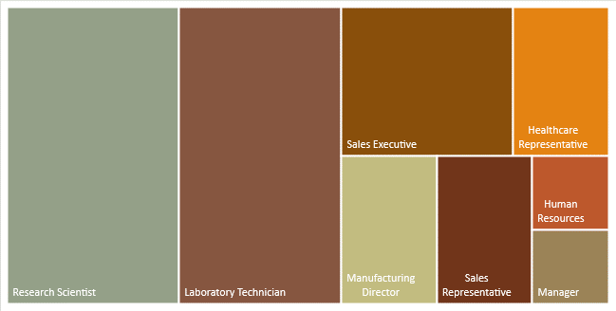

**TYPES OF DEPARTMENT**

The Department is classified into three categories:

1. Human Resource.
2. Research and Development (R&D).
3. Sales.

* Open the data sheet, click on insert pivot table.
* Select Department in rows and CF_attribution in Values.
* Convert the CF_attribution to Percentage
* Once table is created, copy the data into normal tabulation and create a visualization chart.
* Create Pie Chart for the Data
* Go to INSERT-RECOMMENDED CHART-PIE CHART

Tabulation

|  |  |
| --- | --- |
| **Row Labels** | **Sum of CF_attrition** |
| HR | 5.06% |
| R&D | 56.12% |
| Sales | 38.82% |
| **Grand Total** | **100.00%** |

PIE CHART:

**ATTRITION BY AGE**

* The Age is classified five main category
* 25-34
* 35-55
* Under 25
* 45-54
* Over 55
* To obtain the Data go to data set create pivot table
* Add Age band in Rows and sum of CF_attribution in value

|  |  |
| --- | --- |
| **Row Labels** | **Sum of CF_attrition** |
| 25 - 34 | 112 |
| 35 - 44 | 51 |
| Under 25 | 38 |
| 45 - 54 | 25 |
| Over 55 | 11 |
| **Grand Total** | **237** |

**Create visualization chart to express the data.**

* Go to **INSERT-RECOMMENDED CHART-COLUMN CHART**

DASHBOARD:

Dashboard is an overview of collection of data representing in one window

Once all the tabulation and sheets are completed, create a dashboard and add the tabulation and chart.

1) Main dashboard

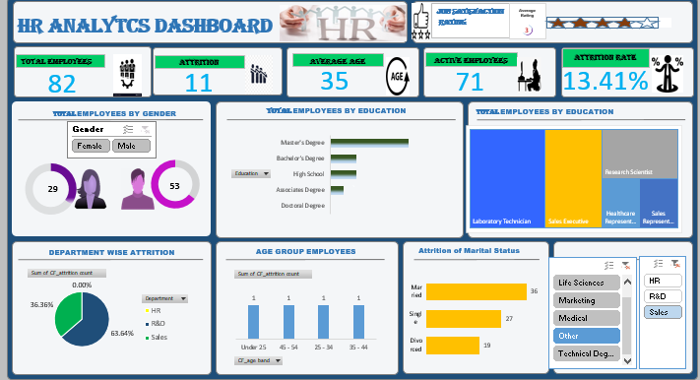

2) Dashboard with Marketing and Sales

